Architectural Strategies
This section aims to describe any design decisions and/or strategies that affect the overall organization of the system and its higher-level structures. These strategies should provide insight into the key abstractions and mechanisms used in the system architecture.
Furthermore, this section will describe the reasoning employed for each decision and/or strategy (possibly referring to previously stated design goals and principles) and how any design goals or priorities were balanced or traded-off.

Use of particular product
- Joomla!
(Figure 1 Joomla! Framework)
  - PHP Framework
    - Collection of software libraries/packages for web and command line applications in PHP.
      - Building a RESTful web services platform
      - Building both simple and complex command line tools
      - Building next generation web applications
  - Model-view-controller web application framework
(Figure 2 Joomla ! Model View Controller)
    - Framework supports dynamic web application development, as libraries for database access, templates, session management, and component reuse. Divides application into three components and defines interaction between them.
  - Content Management System (CMS)
(Figure 3 Framework of a Content Management System )
    - To organise, categorise, and structure information, text, images, documents, audio, and video, to be stored, published, and edited with flexibility and ease.
- Joomla! Content Management System Architecture
(Figure 5 Joomla! CMS Architecture)
  - Consists of the following
    - MySQL Database
      - All your content except image files & documents are stored in the database (MySQL).
    - phpMyAdmin – a graphical interface for MySQL database management
    - Joomla! Framework
      - The Joomla! Framework is a collection of open source software that the Joomla! CMS is built on.
Components, modules and plugins are referred to as Extensions. They ‘extend’ the base Joomla! Framework, either through 3rd party software developed for the framework, or through Joomla! Project developers.
    - Components
      - Components can be thought of as mini ‘Applications’ and are what you will interact with most. Components Example Components: - Users Manager (Protected) - ZOO (3rd Party CCK) - DOCman (3rd Party)
    - Modules
      - Modules are lightweight extensions used in page rendering. They can stand on their own or be used to display data from a Component. Modules are managed from the “Module Manager” (which is itself a Component). Modules Example Modules: - A box of HTML in a sidebar - A list of recently posted articles
    - Plugins
      - Plugins are bits of code that execute at specific event triggers. They are a powerful way of extending the Joomla! Framework. Example Plugins: - User Authentication - “Shortcodes” - Editor Buttons - Email Cloaking Plugins
    - Templates
      - Templates determine the look and feel of the website. They are the ‘icing on the cake’.
    - Website
      - The Website is the graphical interface to it all, and it’s what users will interact with on the front-end, and what administrators will interact with on the back-end.
(http://www.slideshare.net/dustinczysz/joomla-cms-architecture)
- MySQL (Figure 6 MySQL Database Architecture)
  - License
    - GNU General Public License
    - Developed by Oracle Developers – in-depth documentation and strong support
  - Open-source relational database management system (RDBMS)
    - Popular choice for web-applications
    - Central component for LAMP and WAMP open source web application software stack
    - Linux Apache MySQL Perl/PHP/Python (LAMP)
    - Windows Apache MySQL Perl/PHP/Python (WAMP)
- phpMyAdmin
(Figure 1 How phpMyAdmin Connects to MySQL Database)
  - License
    - GNU General Public License
    - http://wiki.phpmyadmin.net/pma/License
  - Handles the administration of MySQL over the Web
  - Supports a wide range of operations on MySQL. Frequently used operations (managing databases, tables, columns, relations, indexes, users, permissions, etc)
  - Administration via the user interface, while you still have the ability to directly execute any SQL statement.
  - Intuitive web interface
  - Support for most MySQL features:
    - browse and drop databases, tables, views, fields and indexes
    - create, copy, drop, rename and alter databases, tables, fields and indexes
    - maintenance server, databases and tables, with proposals on server configuration
    - execute, edit and bookmark any SQL-statement, even batch-queries
    - manage MySQL users and privileges
    - manage stored procedures and triggers
  - Import data from CSV and SQL
  - Export data to various formats: CSV, SQL, XML, PDF, ISO/IEC 26300 - OpenDocument Text and Spreadsheet, Word, LATEX and others
  - Administering multiple servers
  - Creating PDF graphics of your database layout
  - Creating complex queries using Query-by-example (QBE)
  - Searching globally in a database or a subset of it
  - Transforming stored data into any format using a set of predefined functions, like displaying BLOB-data as image or download-link

Appendix

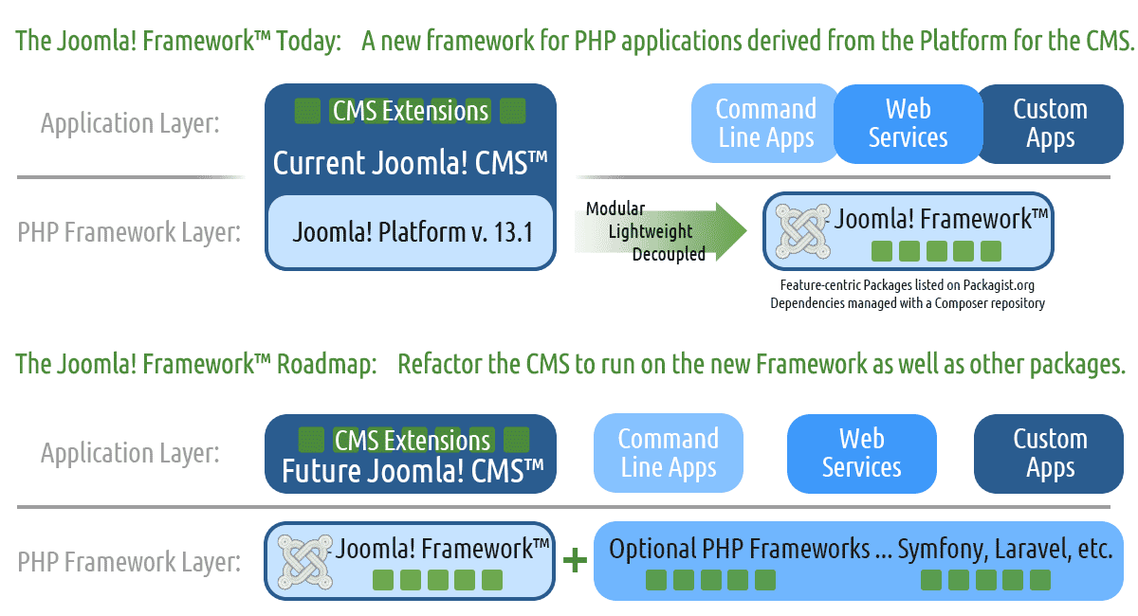
Figure 2 Joomla Framework (http://framework.joomla.org/)

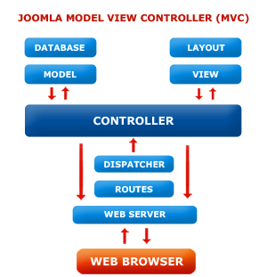
Figure 3 Joomla ! Model View Controller (MVC) (http://www.bluesharksolution.com/images/joomla.png)

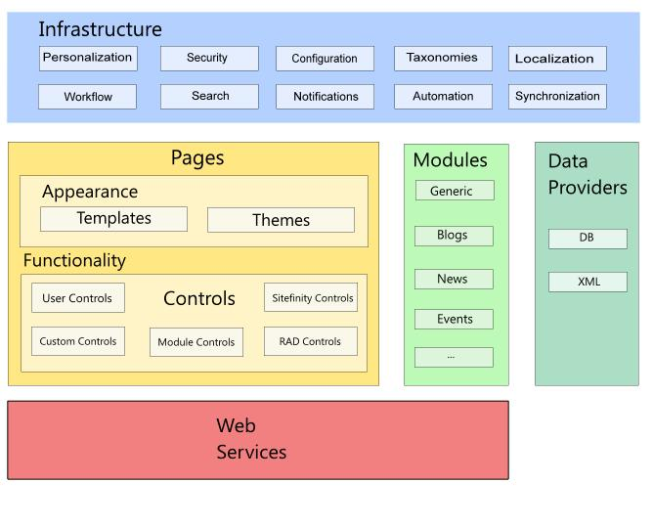
Figure 4 Framework of a Content Management System (CMS)

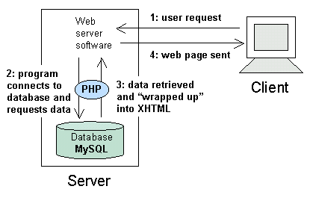
Figure 5 How phpMyAdmin Connects to MySQL Database (http://i.stack.imgur.com/dBXob.gif)
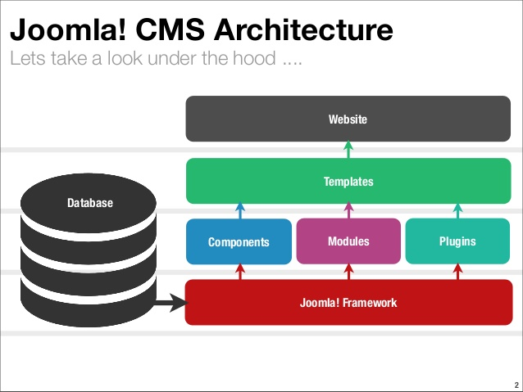
Figure 6 Joomla! CMS Architecture (http://www.slideshare.net/dustinczysz/joomla-cms-architecture)

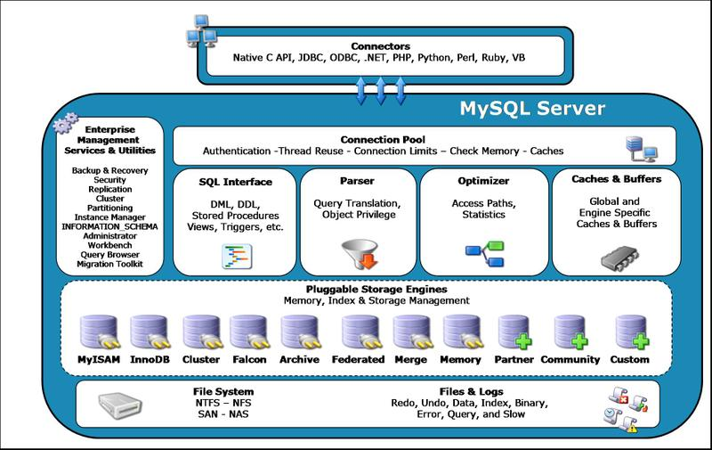
Figure 7 MySQL Database Architecture (http://zurlocker.typepad.com/photos/uncategorized/mysql_pluggable.jpg)

